- \Operation\Trimming station\Trimming station
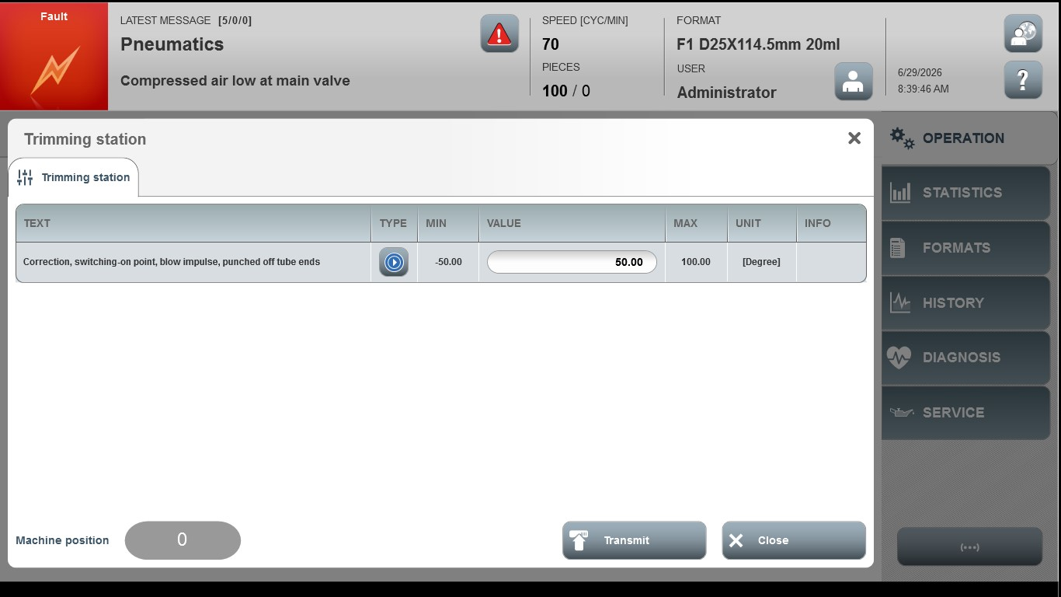
Acceptance criterion | Limits | Pass / Fail: Dev-No. | Date | Initials
Screen matches screenshot | N / A
Correction, switching-on point, blow impulse, punched off tube ends | -50.00 … 100.00

